**JOB-AMIGO**

**A Complete Job Portal**

**Increment-2 (PG-6)**

**Kommineni, Siva Krishna**

**Thallapalli, Ravisha**

**Bandaru, Sarath Chandra**

**Yempalla, Suresh Reddy**

**Summary:**

For the second iteration the main focus is on the selection of the required API’S that are applicable from various job portals available. We are mainly focused on the career builder portal which has lot of API’S available for various criteria’s. We developed the entire GUI design and basic layout for the future services in this iteration. We gathered some validations to the users who register for the security purpose. We store all the details in the SQLite and SQL Server DB. Some soap and rest services are also being employed for the user registration pages and data is stored and retrieved from the DB. Exciting features like Instagram and QR generator are in the foundation level.

**Framework Specification:**

Here the Android GUI frame work mainly consists and follows three stages like searching, retrieving and parsing the required results to the user based on his input. Basically the user criteria of search are like the country or the job category, then list of all the results matching the criteria is available. The user can select the job he wishes to apply and directly apply to the company website by the URL service redirection phenomenon employed. Entire application is developed using the Android frame work for the android users that supports the latest versions. Based on the data parsing of various formats like xml, json are available initially. We parse them into the format using parsers that will be easily understood by the end users.

**Application Specification:**

* **Software Specification**
  + Tools: Visual Studio 2010, Android Development Kit
  + Operating System: Android
  + Development Operating System: Windows 8
  + Programming Language: Java 7.0
  + Databases: SQL Server 2008,SQLite

**Implementation:**

The implementation part typically consisted of three parts. They are:

1. Collection and Implementation of the required API’S for search criteria
2. Retrieving the data from the existing services
3. Parsing and return back it to GUI.

Thus using the above mechanism we successfully used an existing services and API for performing the job search criteria.

In this process the user first enters his choice of country to search for job. It displays all the jobs available under various categories and parameters like pay, Description and employment type.

We also designed the GUI for various services and applications that will be completely implemented in the next iteration.

The following screen shots describe clearly the implementation and progress of the project.

This step is the initial process to login into the system as a user using his credentials.

There are some basic validations which do not allow other users to login to system saying that invalid login for security purpose.

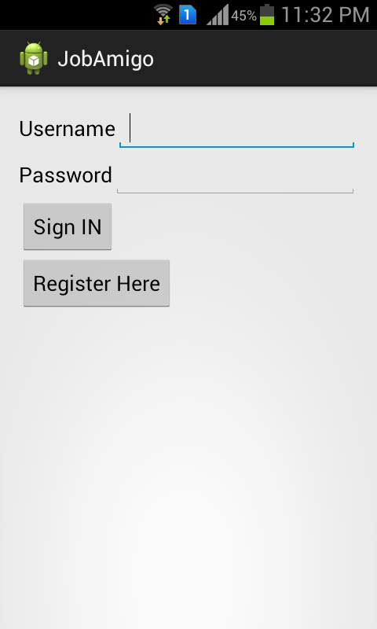 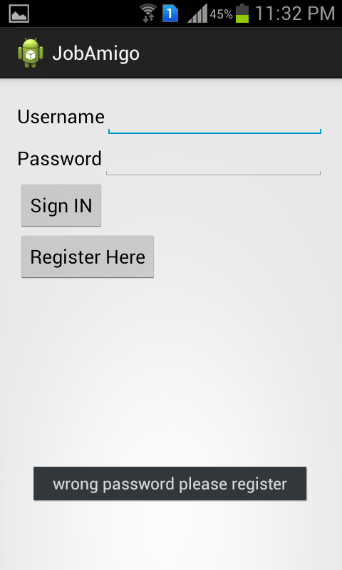

Next if the particular user does not exist he should resister by clicking on the register button which pop a screen as shown below. After filling all the details then click on submit button. It says that the user is successfully registered into the system.

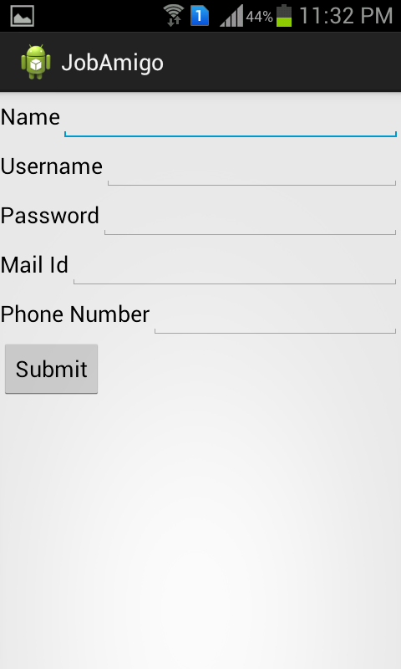 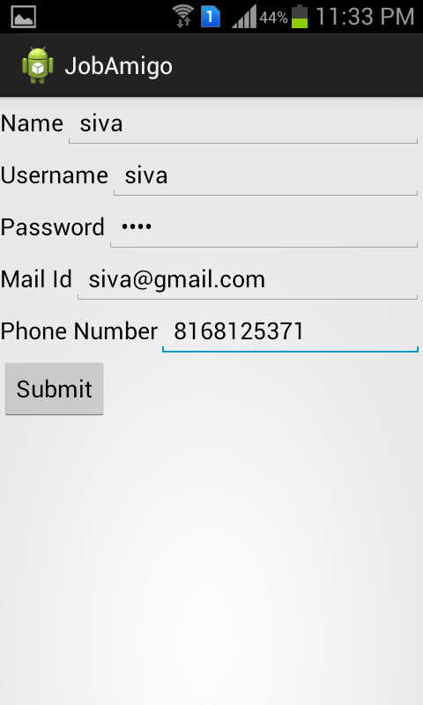

Now the user can perform various operations like job search and see the weather in the particular location and find directions to the destination using the various services available.

They all are under implementation. He can search the jobs based on the country codes and view the list of the available jobs of various categories and under different pay is projected on the screen.

We are using some of the Rest and soap services for creation of the user profiles and the registration of the users into the system using the SQL Server 2008 DB.

We are using the Career builder API for job search for the job seekers.

<http://developer.careerbuilder.com/endpoints/index>

The above link contains various platforms and API’S to perform the search criteria and other requirements for the user.

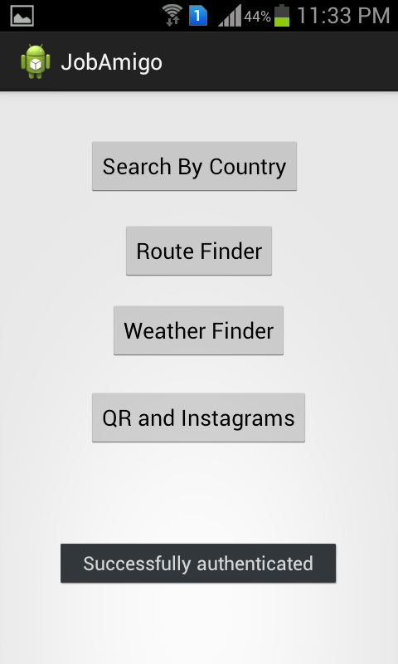 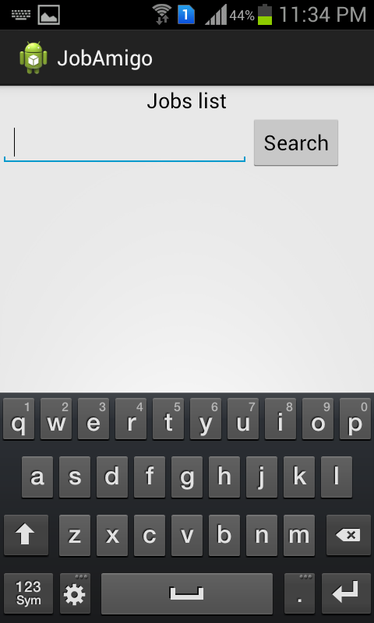

As soon as the user provided his search based on the criteria the result page looks as follows. There is button called Go to Web site. Using this button we can navigate to our required page for application.

We are also planning some interesting aspects like QR code generator and Instagram mechanism for our next iteration.

All the basic lay out has been designed for the features described in the GUI. The below screen shot shows the Instagram and QR code generator mechanism styles.

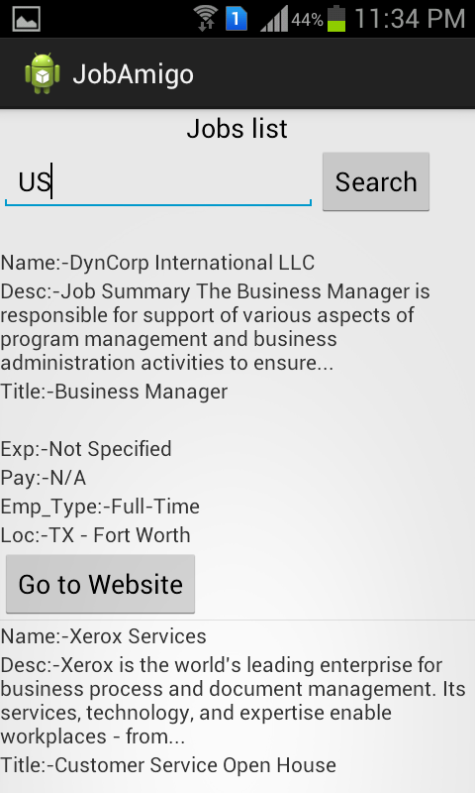

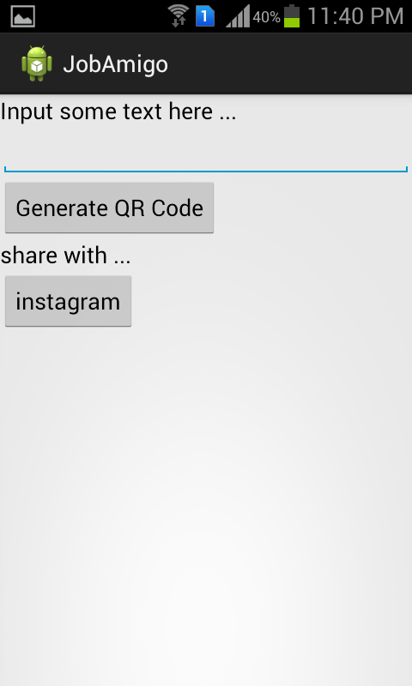

**Project Management:**

All the tasks and their day today increments are being updated in the scrumdo.

* <http://www.scrumdo.com/projects/project/job-amigo/summary>

**Third Increment**

The following tasks will be included for the third increment.

1. Apply to job online from the available description of the job based on criteria– Siva Krishna.
2. Alerting the user that he has applied to job like message and mail alerts. – Ravisha.
3. Text to speech conversion of the required page transitions – Sarath.
4. Usage of open source API’S like google... Weather services etc... – Suresh.
5. QR code and Instagram Implementations to improve security and sharing. – Ravisha & Suresh,
6. Implementation and usage of API’s for easy accessibility for Jobs - Siva Krishna & Sarath.

The above mentioned tasks will be shared equally among all the team members and updated in scrumdo.